Abenezer Namaga

CPE 403-1001 CC1350 LAB 6

Github root directory: https://github.com/Ayertena/AdvEmbededSys

**Date Due: 11/29/2018**

**Task 00:** Getting started

* Installed Uniflash, SensorTag app and sent firmware images to phone.

**Task 01:** Update CC1350 LaunchPad firmware

* Successfully used Uniflash to format the external flash memory, load a hex file and finally updated the firmware using our phone.

**Task 02:** OAD download sub-1GHz firmware images

* Successfully updated firmware to get our device to act as coordinator and Node running a sub-1GHz protocol.

**Task 03:** Running the sub-1GHz firmware images

Youtbe Link: <https://youtu.be/tD01eSbA3NQ>

* Successfully run the firmware images and displayed values on putty terminal.

-----------------------------------------------------------------------------------------------------------

**Task 01:** Importing the WSN Examples

* Imported and built rfwsnConcentrator example.

**Task 02:** Putting it all to work

* Successfully observed change in node value on the concentrator device from putty terminal.

**Task 03:** Change RF Channel

* Successfully changed the RF Channel

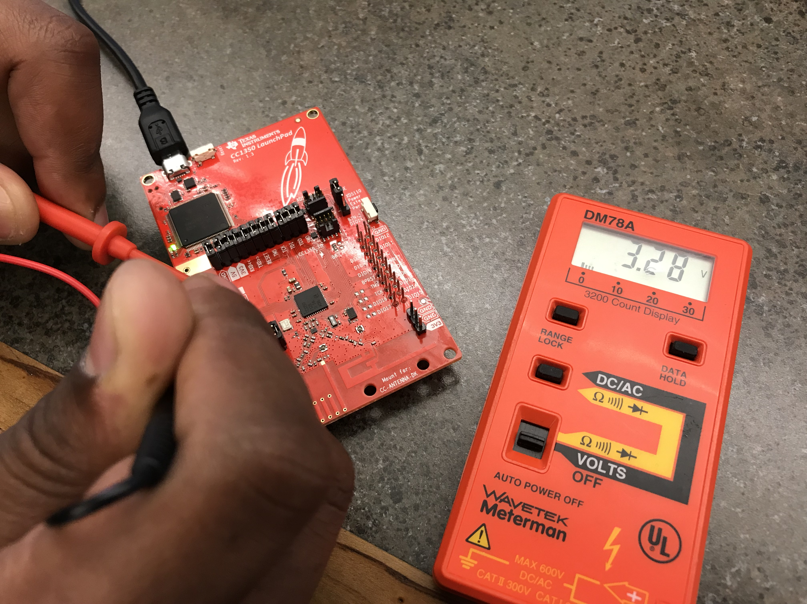**Task 04:** Switch from 2-GFSK 50 kbps to Long Range Mode (LRM)

* Successfully switched to long range on both concentrator and node.

**Task 05:** Measure Power consumption on the node

* Measured the power consumption

**Task 06:** Modify Code Running on the Sensor Controller

* Changed the next execution to wake every 2 tics.